Brandt Cannici Memorial Service
A memorial service has been scheduled for 2 p.m. Sunday, March 1 at the Sparkman Funeral Home: 1029 S Greenville Ave, Richardson, Texas 75081 (972-238-7855).
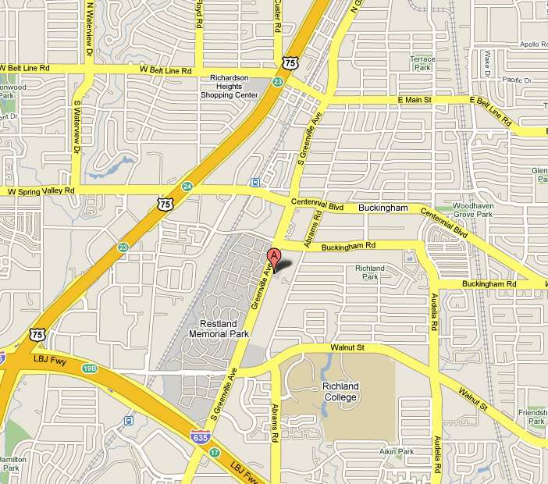
Some people have expressed a desire to send flowers. Instead, the family requests that donations be made to Heart House Dallas- an afterschool program that provides academic support to children of low-income families. Brandt was formerly a dedicated volunteer at the center.
(www.hearthousedallas.org
<https://webmail.utdallas.edu/exchweb/bin/redir.asp?URL=http://www.hearthousedallas.org/> )
Jim

